**CIS-350  
Infrastructure Technologies**

**Lab 1 Report**

**Student Name**: **Regis Wilson**

**You must use this template to hand in Lab1 Report.**

1. Insert the *Lab1_Tree* file from p. 25 of the Lab1 instructions into the space provided or use the *Alt-PrtScr* keys to capture the full screen output (full window) from command *TYPE Lab1_Tree* on p. 25 and paste that window here.



I am not sure if this file will be accessible so I attached a screenshot as well.

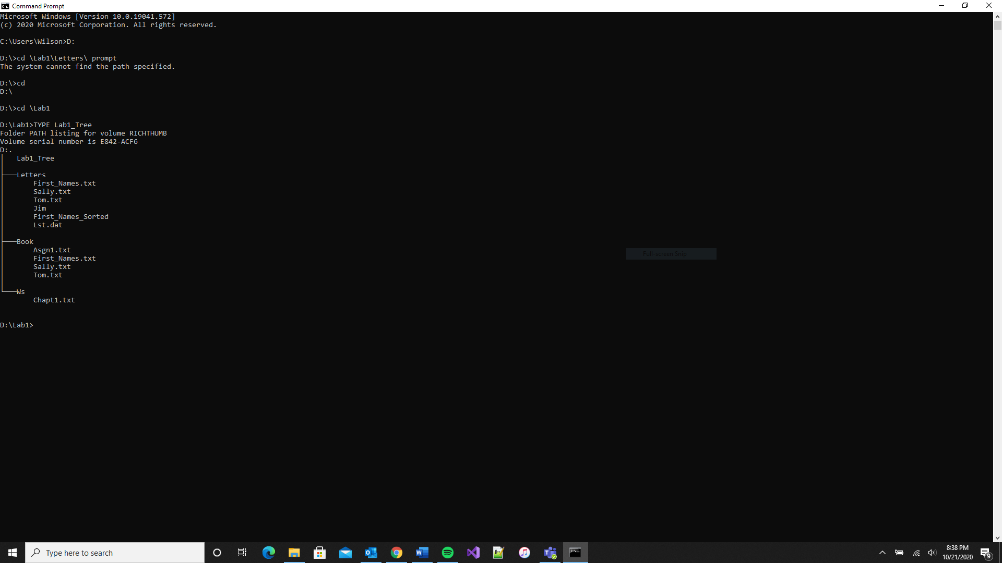

1. Below you have the following directory structure. At the top there is the root directory denoted by a backslash "\". *CLASSES*, *DOS*, *WINDOWS*, *BOOK*, *FINANCE*, etc. are the names of subdirectories residing under the root directory; *CONFIG.SYS* is the name of a file residing in the root directory, and *chkdsk.exe*, *CHAPTER1.DOC*, *Q.EXE*, etc. are the names of the files stored in the subdirectories. The system prompt displays"*C:****\****>*" which means that the current/default drive is *C* and the current/default directory is the root directory "**\**". The root directory "**\**" is just the origin for other directories/subdirectories.

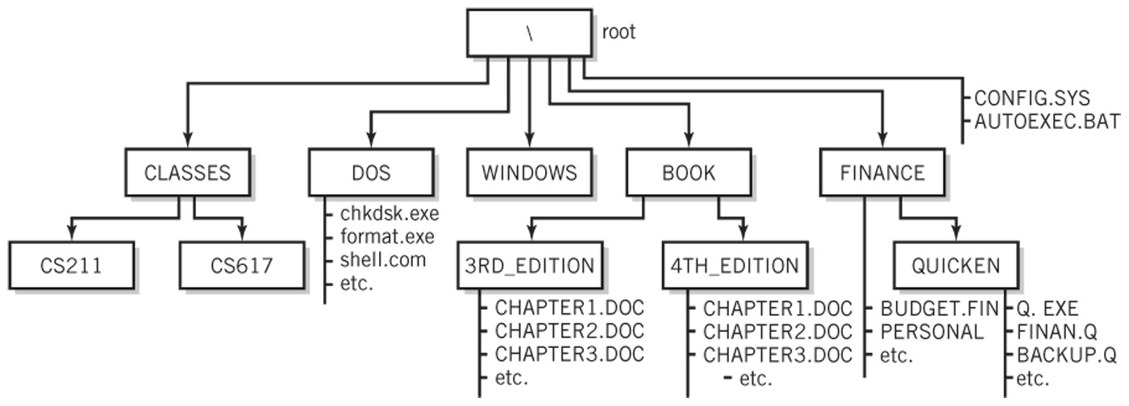

All questions (a) through (j) are based on the above directory diagram. For questions (a) through (f) assume the prompt "*C:* *>*" is displayed.

1. Write a command to copy file *CONFIG.SYS* to directory *DOS*. The copied file should have the same name as the original file, i.e., *CONFIG.SYS*.

____________ COPY CONFIG.SYS \DOS ______________

1. Write a command to copy a file *CONFIG.SYS* to directory *QUICKEN*. The copied file should have new name *CONFIG1.SYS*.

_________COPY CONFIG.SYS \FINANCE\QUICKEN\CONFIG1.SYS ______

1. Write a single command to copy all files whose names start with letter *C* from directory *4TH_EDITION* to directory *FINANCE*.

_______ BOOK\4TH_EDITION\COPY C* \FINANCE _________

1. Write a single command to erase from directory *4TH_EDITION* all files whose names start with letter *C*.

_________ \BOOK\4TH_EDITION ERASE C* ___________

1. How many files would be erased by the command from p. (d) above? _______3______
2. Assume that *AUTOEXEC.BAT* is a large file. What command would you use to display the contents of the file one screen at a time (to prevent the output from scrolling off the screen)? ______ TYPE AUTOEXEC.BAT | MORE _____
3. Look at the diagram. Assume that prompt "*C:\FINANCE\QUICKEN>*" is displayed, meaning that the current/default drive is *C* and the current/default directory is *\FINANCE\QUICKEN*. Write two separate *SORT* commands. Each of the two commands would accept input from file *BACKUP.Q*. However, the first command would route the output to file *BACKUP1.Q*, and the second one would append the output to file *BACKUP2.Q*. _

SORT<BACKUP.Q >BACKUP1.Q

SORT<BACKUP.Q>>BACKUP2.Q

___________

1. Look at the diagram. Assume that prompt "*C:\FINANCE\QUICKEN>*" is displayed. Write the command which would change the current directory to *FINANCE*. __________CD **..**
2. Look at the diagram. Assume that prompt "*C:\FINANCE>*" is displayed. In the space provided, sketch the directory structure with the subdirectory and file names which would command *TREE* /F generate.

| BUDGET.FIN

| PERSONAL

| QUICKEN

| Q.EXE

| FINAN.Q

| BACKUP.Q

1. Now assume that the "C:\ " prompt is displayed. Describe what a command

*DIR | SORT > DirList* would do.

The commands will route the output from the DIR command to an input to the SORT command. The SORT command will sort the directory lines in ascending order since descending was not specified and be sent or routed to where DirList is. Nothing would be shown on the screen and the output would be stored or kept in the DirList file. It is also important to note that if file DirList does not exist then it will be created and kept accordingly, if it has been created already that file will be overwritten.

1. Optional. Briefly describe any issues with the commands which did not work. Point me to the specific pages and suggest changes. Thanks.